

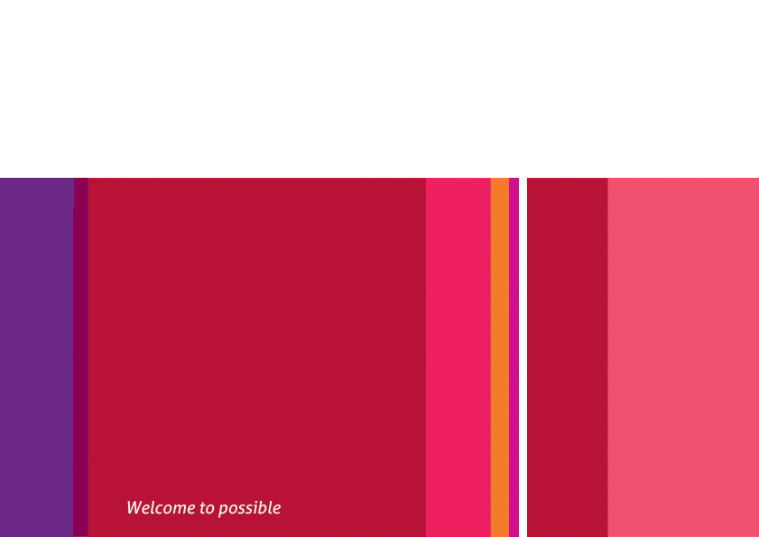

Astra Test – Librarian Features – Editing Resources

Test File ID: RES100

Astra Version(s): 1.0.7

July 31, 2013

Doc ID: **1C30EA4B-871D-473A-829F-573C42AA49AC**

Description

This suite contains test cases regarding the Admin’s ability to create and edit Resources in Astra.

# Create a Resource

|  |  |  |
| --- | --- | --- |
| Instructions | Expected Result | Pass / Fail |
| **Log in to the site as a Librarian.** | You should see the Home Page as normal. |  |
| Click the *Admin* Link. | ??? |  |
| Etc… |  |  |

# Edit a Resource

TBA

# Add a Cover Image to a Resource

TBA

# Delete a Resource